**12th International Language and Development Conference**

**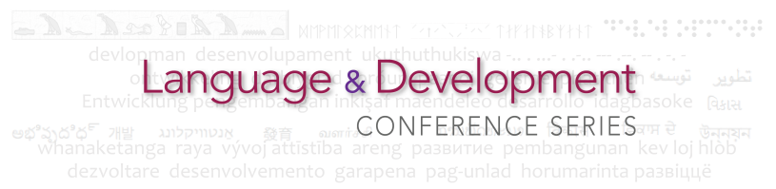LANGUAGE AND THE SUSTAINABLE DEVELOPMENT GOALS**

**27, 28, 29 November 2017, Senegal**

**PRESENTER PROPOSAL FORM**

Complete the following form and submit it to [LDC2017@britishcouncil.sn](mailto:LDC2017@britishcouncil.sn) no later than midnight GMT on 19 May 2017. All proposals will be anonymised and considered by a selection panel. Decisions will be announced at the end of June 2017.

**Your name**, exactly as you would like it to appear in the Conference programme and name tag.   
Do not include academic or other titles such ‘Dr’ or ‘Professor’.

|  |
| --- |
|  |

**Your email address (mandatory field)**

|  |
| --- |
|  |

**Your institution/organisation (optional field)**

|  |
| --- |
|  |

**Your position in the institution/organisation (optional field)**

|  |
| --- |
|  |

**The title of your presentation** **(maximum 25 words)**

|  |
| --- |
|  |

**Type of presentation (tick one)**

|  |  |
| --- | --- |
| Talk / lecture |  |
| Workshop |  |
| Other (please specify) |  |

**The sub-theme that most closely matches your presentation (tick one)**

|  |  |
| --- | --- |
| 1. Multilingualism for Quality, Equitable and Inclusive Education |  |
| 1. Language, Skills and Sustainable Economic Growth |  |
| 1. Communication, Peace and Justice |  |

**Abstract of your presentation** **(maximum 300 words)**. The abstract is extremely important because it determines whether your proposal will be accepted. Clarify the context in which your presentation is set. Explain what the presentation is based on (research data, for example, or something else?). Give an indication of your conclusions. The abstract should be in English or French, please, but presentations may be made in other languages (see below).

Papers will be selected on the following criteria:

* Relevance, showing a clear link to the central conference theme and chosen sub-theme
* Originality
* Evidence-based
* Clarity, coherence and organisation
* Potential for audience interaction/involvement.

|  |
| --- |
| **generic_quarter.png**  **State the number of words in this abstract: \_\_\_**  **Abstracts longer than 300 words cannot be considered.** |

**Your bio-data**, maximum 50 words. Do not repeat any of the information which you have already given above (name, institution/organisation and position). Use the first person singular (‘I have been … I am interested in …’ etc.)

|  |
| --- |
| **State the number of words in this bio-data: \_\_\_** |

**The language in which you wish to make your presentation (tick one)**

|  |  |
| --- | --- |
| English |  |
| French |  |
| Other (please specify) |  |

Where a presentation is delivered in a language other than English or French, the organisers will make every effort to find an interpreter. More details about language provision during the conference will be made available at a later date.

**Technical equipment** required for your session **(tick any that are required)**

|  |  |
| --- | --- |
| LCD projector and screen |  |
| Laptop |  |
| Audio out for purposes of showing video clips |  |
| Other (please specify) |  |

NB If you plan to use Apple / Mac devices, please ensure that you carry a suitable AV converter for LCD projectors.

**Deadline for submissions**

Now please send this completed form to [LDC2017@britishcouncil.](mailto:LDC2017@britishcouncil.)sn no later than 19 May 2017

**For the latest information on the conference**

Further details are available on the conference website where you can find the latest information. The website will be updated regularly.

**Website:** [www.britishcouncil.com.sn/en/programmes/language-development-conference-2017](http://www.britishcouncil.com.sn/en/programmes/language-development-conference-2017)

**Email:** [LDC2017@britishcouncil.sn](mailto:LDC2017@britishcouncil.sn)

