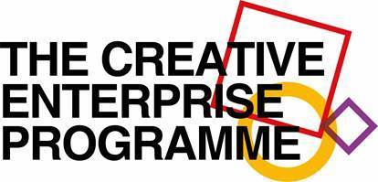

Nesta and British Council

Creative Enterprise Program - Participant Application Form

The Creative Enterprise Program is a three-day workshop designed to help you explore your business idea and develop a specific business plan.
Based on the Creative Enterprise Toolkit and led by an experienced Nesta facilitator, the workshop will feature creative business methods and tools, interactive activities, and a series of exercises supported by peer-to-peer learning opportunities in Group.
The Creative Enterprise Program is for entrepreneurs who have a solid business idea but have not started yet, are in the early stages of starting a business (0 to 3 years old), or have a business creative that is not yet stable and in which you anticipate significant changes.
The focus is on creative sectors such as advertising, architecture, arts and culture, crafts, design, fashion, games, music, publishing, technology, television and cinema.

Dates of Training: 3 - 4 - 5 October 2018 at the House of Urban Cultures (MCU)

About
Name
Address
Country
Cell number
E-mail adress
Age | 18 - 29 | 30 - 39 | 40 - 49 | 50+
How do you evaluate your English skills?
Spoken | elementary | professional | Fluent
Written | elementary | professional | Fluent
D’autres langues ?
Training
Do you have a disability that you would like to talk to us about, or do you need additional help once you are admitted to the program?

About your creative business or business idea
Name of the company or business idea
If so, please share the links that relate to your business (for example: website social media)
Please describe your company or business idea (150 words maximum)
Who are your customers, what is specific about what you do, what are the benefits and how are the services offered?

What is the number one advantage for the customer? (150 words maximum)
What are the main challenges you face today? (150 words maximum)
What do you like about your business or business idea? (150 words maximum)
How long have you been working on your business or business idea?
Who else is involved in the business or business idea, as an interested party or partner, and what is their role?
If so, how much has your business earned in the last six months?
The most successful entrepreneurs took risks and failed. What risks did you take and what did you learn by taking risks?
Where would you like your business to be in 5 years?
What could prevent you from achieving your goals?

Your expectations for the Creative Enterprise Program
What do you expect from this program?
If your application is successful, what can you teach us?

